1. Create an S3 bucket and upload some objects to S3.

Amazon S3 (Simple Storage Service)
What is Amazon S3?
Amazon S3 (Simple Storage Service) is a cloud storage service provided by AWS. It is used to store and retrieve files such as documents, images, videos, backups, and application data from anywhere over the internet.
S3 is highly secure, scalable, durable, and cost-effective.

TASK 1: Create an S3 Bucket and Upload Objects
Objective
To create an Amazon S3 bucket and upload files into it.

Theory
An S3 bucket is a container used to store files (objects) such as documents, images, videos, and backups. Every object in Amazon S3 is stored inside a bucket.

Prerequisites
- AWS account
- IAM user with S3 permissions
- Internet connection

Step 1: Log in to AWS Console
- Open your browser.
- Visit the AWS Management Console.
- Sign in with your AWS account.

Step 2: Open Amazon S3
- In the search bar, type S3.
- Click Amazon S3.

Step 3: Create a Bucket
- Click Create bucket.
- Enter the following details:
Bucket name: venu-demo-bucket-001
AWS Region: Asia Pacific (Mumbai) ap-south-1
- Leave the remaining settings as default.
- Click Create bucket.
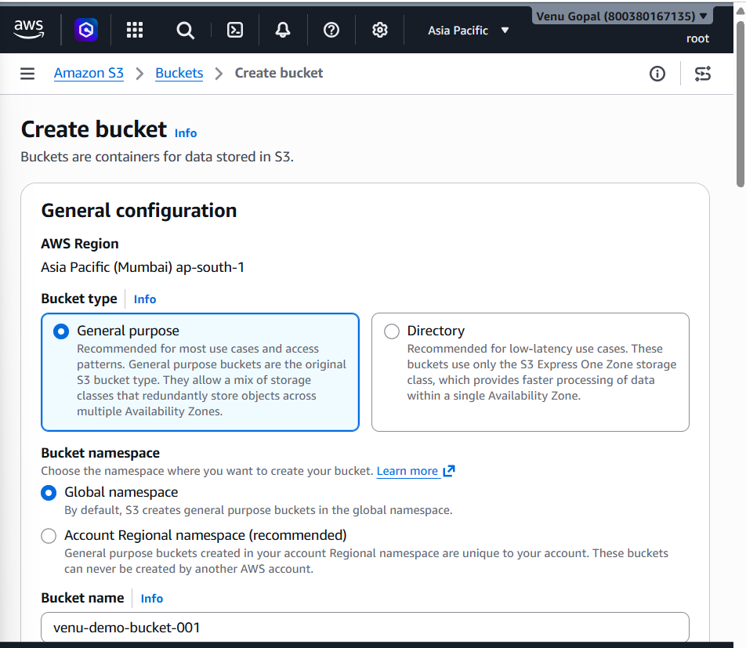

Step 4: Verify the Bucket
You can now see your bucket in the S3 bucket list.
Example:
venu-demo-bucket-001
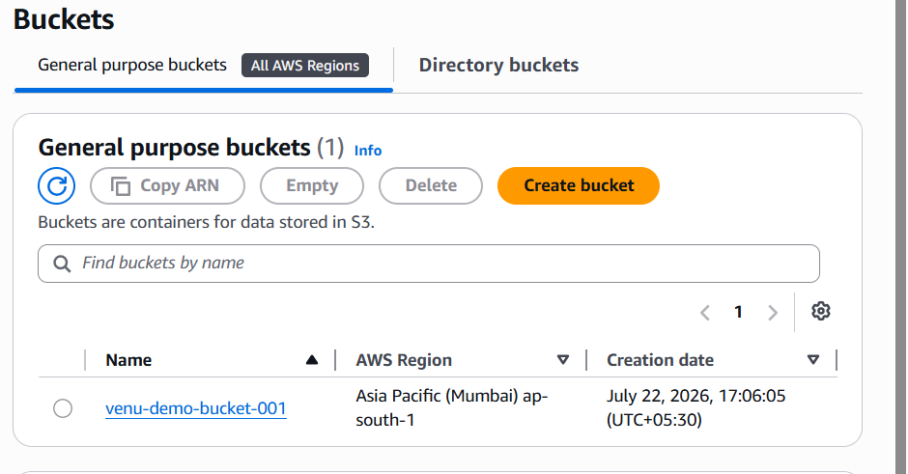

Step 5: Upload Objects to the Bucket
- Click on the bucket name.
- Click Upload.
- Click Add files.
- Select files from your system, for example:
test.txt
image.jpg
sample.pdf
- Click Upload.
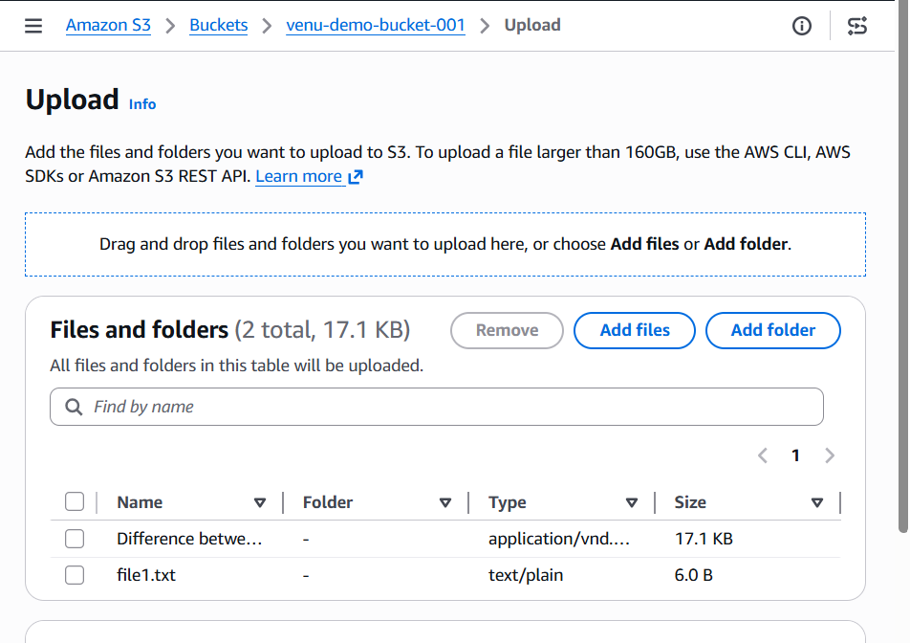

Step 6: Verify Uploaded Objects
After the upload is completed, the files will appear inside the bucket.
Example:
test.txt
image.jpg
sample.pdf

AWS CLI Commands
Create a bucket:
aws s3 mb s3://venu-demo-bucket-001
Upload a file:
aws s3 cp test.txt s3://venu-demo-bucket-001
List files:
aws s3 ls s3://venu-demo-bucket-001

Expected Output
upload: ./test.txt to s3://venu-demo-bucket-001/test.txt
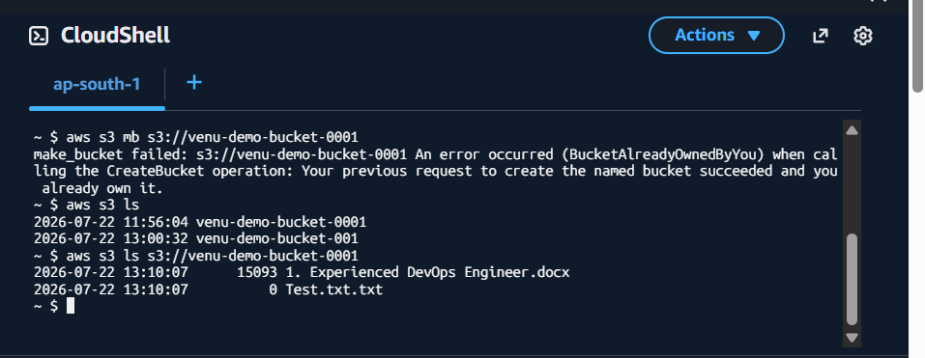

Result
The Amazon S3 bucket was created successfully, and files were uploaded to the bucket.

Screenshot
Paste screenshots of:
- S3 dashboard
- Bucket creation page
- Uploaded objects page

Key Learning
- Learned how to create an S3 bucket.
- Learned how to upload files using the AWS Console.
- Learned how to upload files using AWS CLI.

2.Deploy a static website in the S3 bucket.
Objective
To host a static website using an Amazon S3 bucket.

Theory
A static website contains only front-end files such as:
- HTML
- CSS
- JavaScript
- Images
Amazon S3 can host these files and make them accessible over the internet.

Step 1: Create an HTML File
Open Notepad and paste the following code:
<!DOCTYPE html>
<html>
<head>
<title>My First S3 Website</title>
</head>
<body>
<h1>Welcome to AWS S3 Static Website Hosting</h1>
<p>This website is hosted using Amazon S3.</p>
</body>
</html>
Save the file as:
index.html

Step 2: Upload the HTML File
- Open the AWS Console.
- Go to S3.
- Open your bucket:
venu-demo-bucket-0001
- Click Upload.
- Select the file:
index.html
- Click Upload.
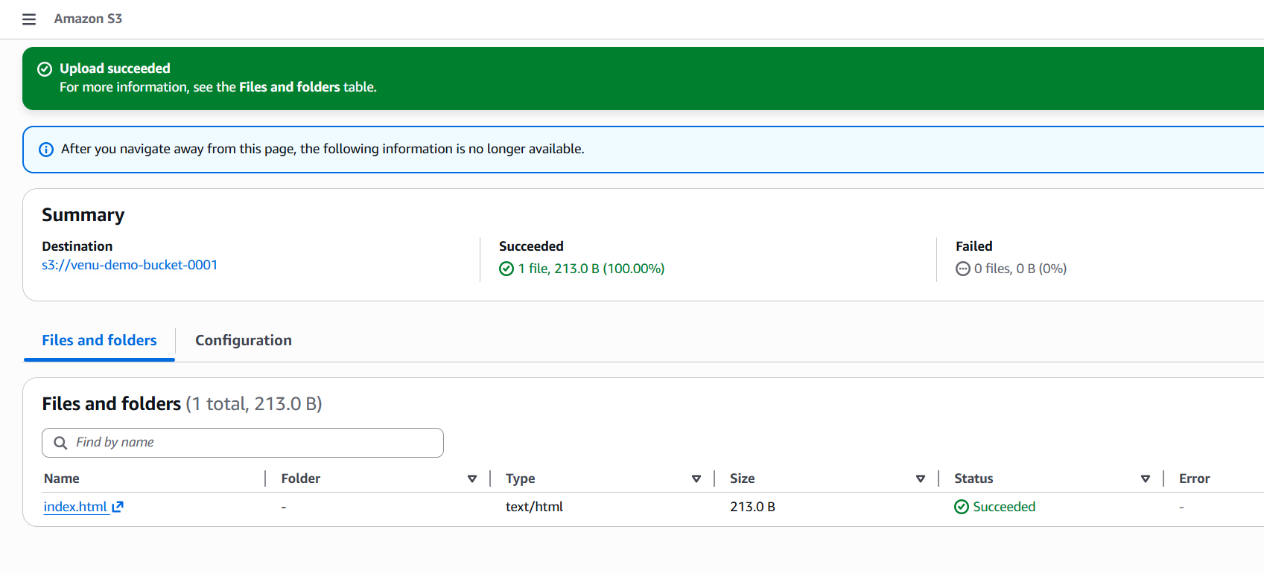

Step 3: Enable Static Website Hosting
- Open your bucket.
- Click the Properties tab.
- Scroll down to Static website hosting.
- Click Edit.
- Select:
Enable
- In Hosting type, choose:
Host a static website
- Enter:
Index document: index.html
- Click Save changes.
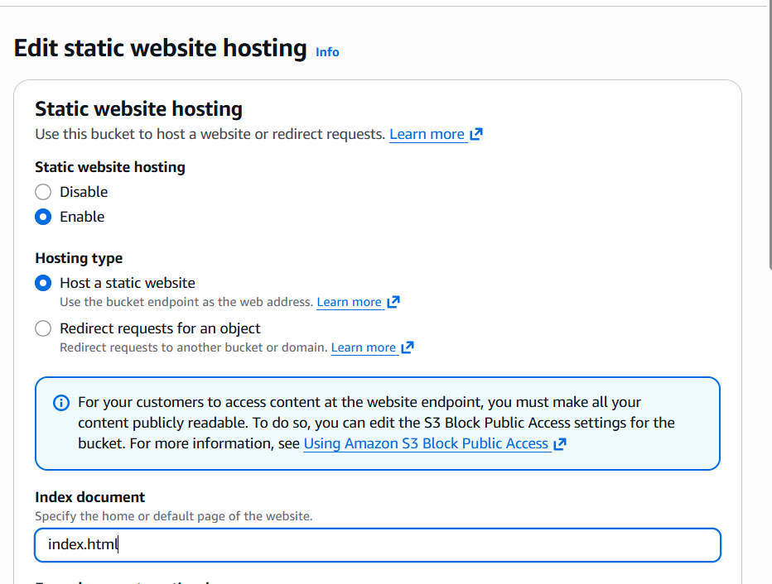

Step 4: Make the Website Public
Go to the Permissions tab.
Under Bucket policy, click Edit and paste:
{
"Version": "2012-10-17",
"Statement": [
{
"Sid": "PublicRead",
"Effect": "Allow",
"Principal": "*",
"Action": "s3:GetObject",
"Resource": "arn:aws:s3:::venu-demo-bucket-0001/*"
}
]
}
Click Save changes.
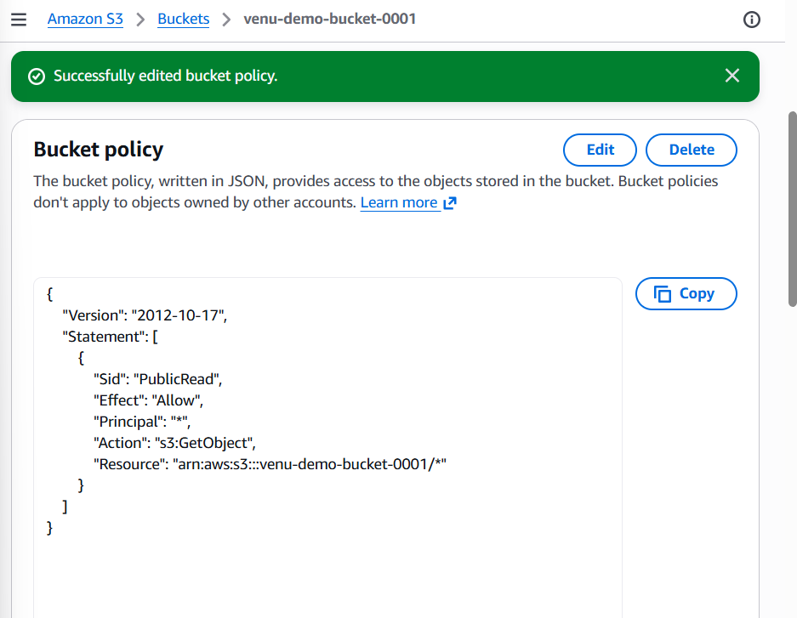

Step 5: Disable "Block Public Access"
- Open the Permissions tab.
- Click Edit under Block public access.
- Uncheck:
Block all public access
- Confirm and save.
⚠️ This step is required only for static website hosting.
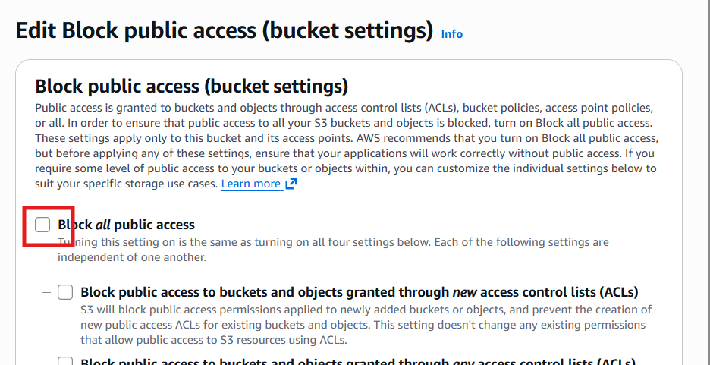

Step 6: Open the Website
Go to the Properties tab and scroll to Static website hosting.
You will see a URL like:
http://venu-demo-bucket-0001.s3-website-ap-south-1.amazonaws.com
Click the URL to open your website.

AWS CLI Commands
Upload the website file:
aws s3 cp index.html s3://venu-demo-bucket-0001
Verify:
aws s3 ls s3://venu-demo-bucket-0001

Expected Output
The browser should display:
Welcome to AWS S3 Static Website Hosting

This website is hosted using Amazon S3.
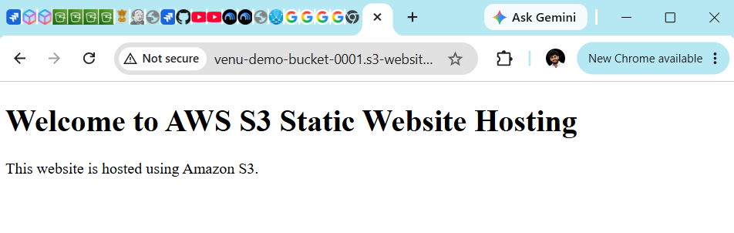

Result
The static website was successfully deployed and hosted using Amazon S3.

Screenshot
Take screenshots of:
- index.html file.
- Static website hosting settings.
- Bucket policy.
- Website URL.
- Website opened in the browser.

Key Learnings
- Learned how to host a static website using Amazon S3.
- Learned how to configure bucket policies.
- Learned how to enable public access.
- Learned how S3 serves HTML files over the internet.

3.Enable cross-region replication on S3 buckets.
Objective
To automatically copy objects from one S3 bucket to another bucket in a different AWS region.

Theory
Cross-Region Replication (CRR) automatically copies files (objects) from one bucket to another bucket located in a different AWS region.
For example:
Source Bucket (Mumbai) → Destination Bucket (Singapore)
Advantages of CRR
- Backup and disaster recovery.
- Improved availability.
- Faster access for users in different regions.
- Compliance requirements.
Note: Versioning must be enabled on both buckets before enabling replication.

Step 1: Create a Second Bucket
Create another bucket with a unique name.
Field | Value
Bucket name | venu-demo-bucket-backup-0001
Region | Asia Pacific (Singapore) (ap-southeast-1)
Click Create bucket.
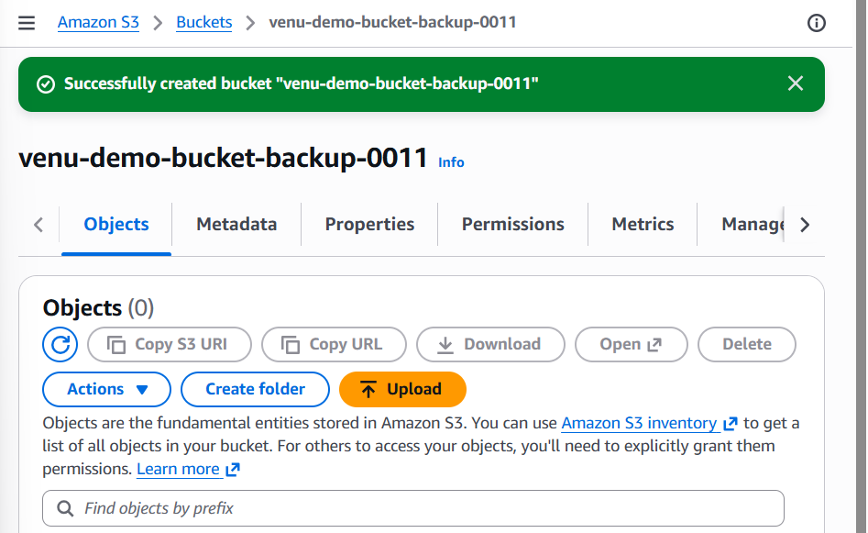

Step 2: Enable Versioning on the Source Bucket
- Open your source bucket:
venu-demo-bucket-0001
- Open the Properties tab.
- Scroll down to Bucket Versioning.
- Click Edit.
- Select Enable.
- Click Save changes.
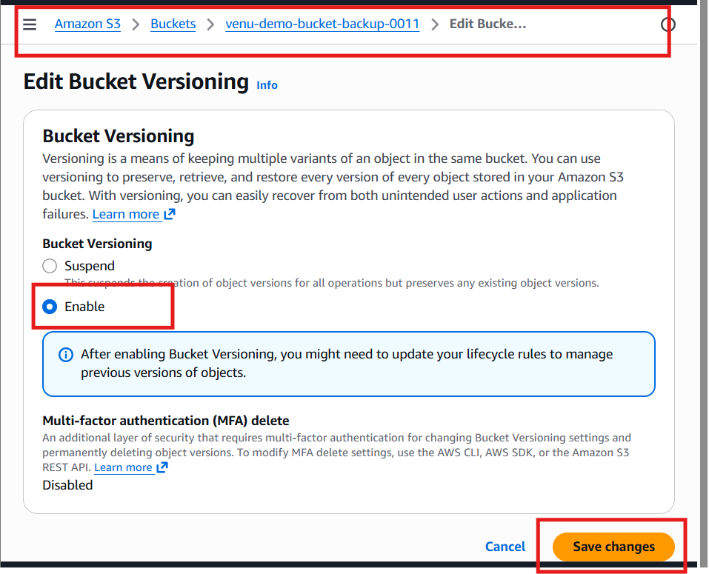

Step 3: Enable Versioning on the Destination Bucket
Repeat the same steps for:
venu-demo-bucket-backup-0001
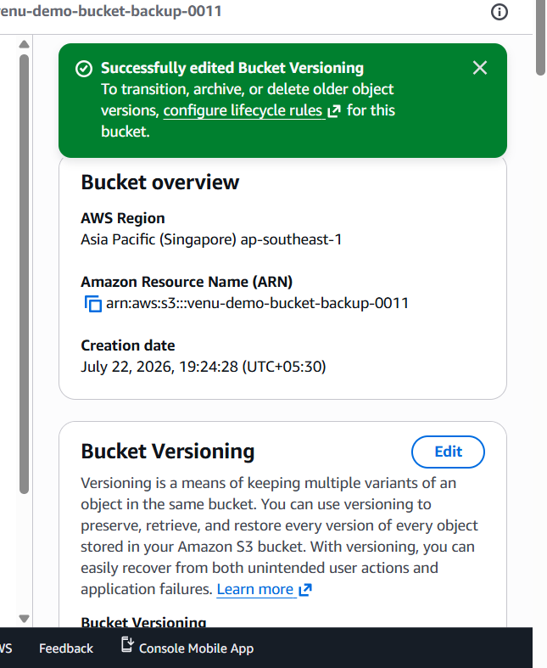

Step 4: Create a Replication Rule
- Open the source bucket.
- Open the Management tab.
- Scroll to Replication rules.
- Click Create replication rule.
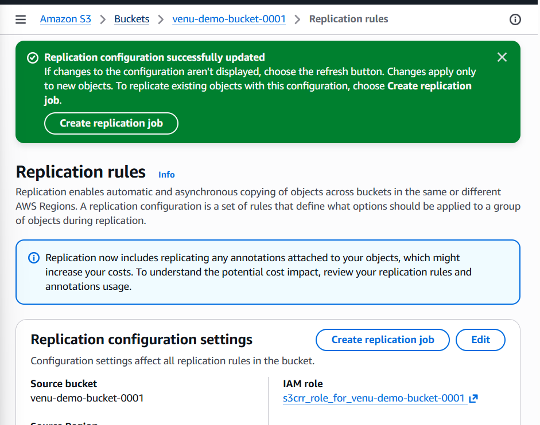

Step 5: Configure the Rule
Fill in the details:
Option | Value
Rule name | replication-rule-1
Rule status | Enabled
Choose a rule scope | Apply to all objects in the bucket
Click Next.

Step 6: Choose the Destination Bucket
Select:
venu-demo-bucket-backup-0001
Choose the region:
Asia Pacific (Singapore)

Step 7: Create an IAM Role
Select:
Create new IAM role
AWS automatically creates the required permissions.
Click Save.

Step 8: Test Replication
Upload a file such as:
sample.txt
to:
venu-demo-bucket-0001
Wait a few minutes and check:
venu-demo-bucket-backup-0001
The same file should appear in the destination bucket.
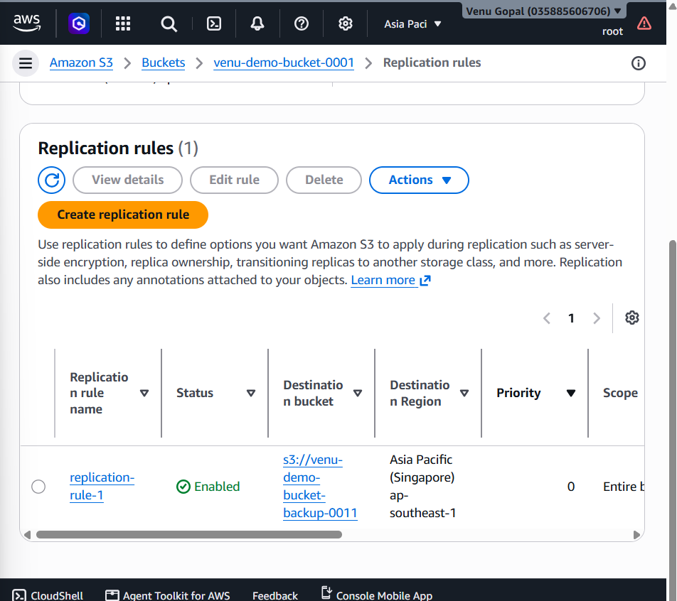

AWS CLI Commands
Enable versioning:
aws s3api put-bucket-versioning \
--bucket venu-demo-bucket-0001 \
--versioning-configuration Status=Enabled
aws s3api put-bucket-versioning \
--bucket venu-demo-bucket-backup-0001 \
--versioning-configuration Status=Enabled
Verify:
aws s3api get-bucket-versioning \
--bucket venu-demo-bucket-0001
Expected output:
{
"Status": "Enabled"
}
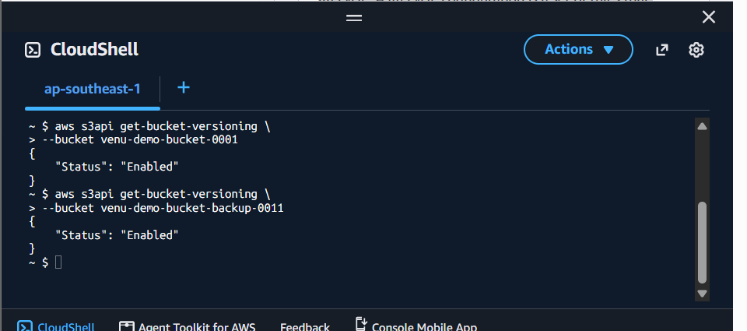

Result
Cross-Region Replication was successfully configured between the source bucket and the destination bucket.

Screenshots to capture
- Source bucket details.
- Destination bucket creation.
- Versioning enabled on both buckets.
- Replication rule configuration.
- Replicated objects in the destination bucket.

Key Learnings
- Learned how to configure Cross-Region Replication.
- Learned that versioning is mandatory for replication.
- Learned how data can be copied automatically between AWS regions.

4.Configure a bucket policy so only the Admin user can see the objects of the S3 bucket.
Objective
Configure a bucket policy to allow access only to the Admin user for the S3 bucket objects.

Theory
An S3 bucket policy is a JSON document that controls who can access the bucket and what actions they can perform. Bucket policies are attached directly to the bucket.
In this task, access is restricted so that only the Admin user can view and manage objects stored in the S3 bucket.

Prerequisites
- AWS account access.
- S3 bucket created:
venu-demo-bucket-0001
- IAM Admin user available.
Note: In this lab, the AWS root account was used instead of an IAM Admin user.

Step 1: Open Amazon S3
- Sign in to the AWS Management Console.
- Switch to the region:
Asia Pacific (Mumbai) – ap-south-1
- Open Amazon S3.
- Select the bucket:
venu-demo-bucket-0001

Step 2: Open the Permissions Tab
- Click the Permissions tab.
- Scroll down to Bucket policy.
- Click Edit.

Step 3: Find Your AWS Account ID
- Click your account name in the upper-right corner.
- Copy the 12-digit AWS Account ID.
Example:
123456789012

Step 4: Add the Bucket Policy
Delete the existing policy and paste the following JSON.
Replace 123456789012 with your account ID.
{
"Version": "2012-10-17",
"Statement": [
{
"Sid": "RootAccessOnly",
"Effect": "Allow",
"Principal": {
"AWS": "arn:aws:iam::123456789012:root"
},
"Action": "s3:*",
"Resource": [
"arn:aws:s3:::venu-demo-bucket-0001",
"arn:aws:s3:::venu-demo-bucket-0001/*"
]
}
]
}

Step 5: Save the Policy
- Click Save changes.
- Verify that the policy is attached successfully.
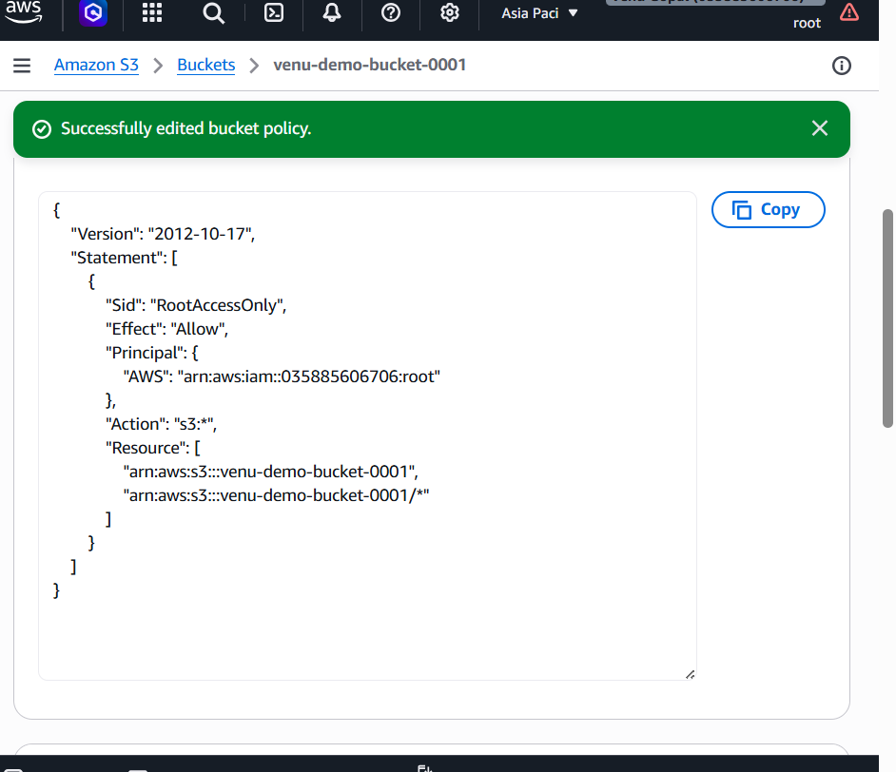

AWS CLI Commands
Display the bucket policy:
aws s3api get-bucket-policy \
--bucket venu-demo-bucket-0001
Delete the bucket policy:
aws s3api delete-bucket-policy \
--bucket venu-demo-bucket-0001
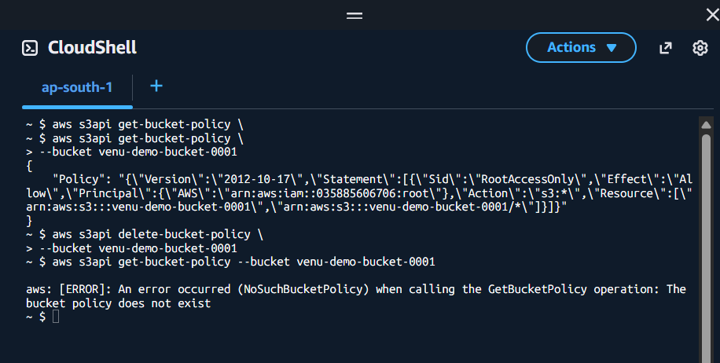

Expected Result
The bucket policy is attached successfully, and only the configured user can access the bucket objects.

Screenshots to Capture
- S3 bucket list.
- Permissions tab.
- Bucket policy JSON.
- Successful policy attachment.

Key Learnings
- Learned how bucket policies control access to S3 buckets.
- Learned how to restrict bucket access.
- Learned the difference between IAM policies and bucket policies.

Lab Note
The bucket was previously configured for static website hosting using a public-read policy. Be

5.Set up lifecycle policies to automatically transition or delete objects based on specific criteria.
Objective
Create an S3 lifecycle rule to automatically delete or move objects after a specified number of days.

Theory
An S3 lifecycle policy helps manage objects automatically. It can:
- Move objects to cheaper storage classes.
- Delete old objects automatically.
- Remove incomplete uploads.
Lifecycle rules help reduce storage costs.

Step 1: Open Amazon S3
- Log in to the AWS Management Console.
- Switch to the region:
Asia Pacific (Mumbai) – ap-south-1
- Open the bucket:
venu-demo-bucket-0001
- Click the Management tab.

Step 2: Create a Lifecycle Rule
- Under Lifecycle rules, click:
Create lifecycle rule
- Enter the lifecycle rule name:
delete-old-objects
- Select:
Apply to all objects in the bucket
- A warning message will appear.
- Check:
I acknowledge that this rule will apply to all objects in the bucket.

Step 3: Choose Lifecycle Actions
Select:
✅ Expire current versions of objects
Leave all other options unchecked.
Click Next.

Step 4: Configure Expiration
Enter:
30
days.
This means all objects older than 30 days will be deleted automatically.

Step 5: Save the Rule
Click:
Create rule
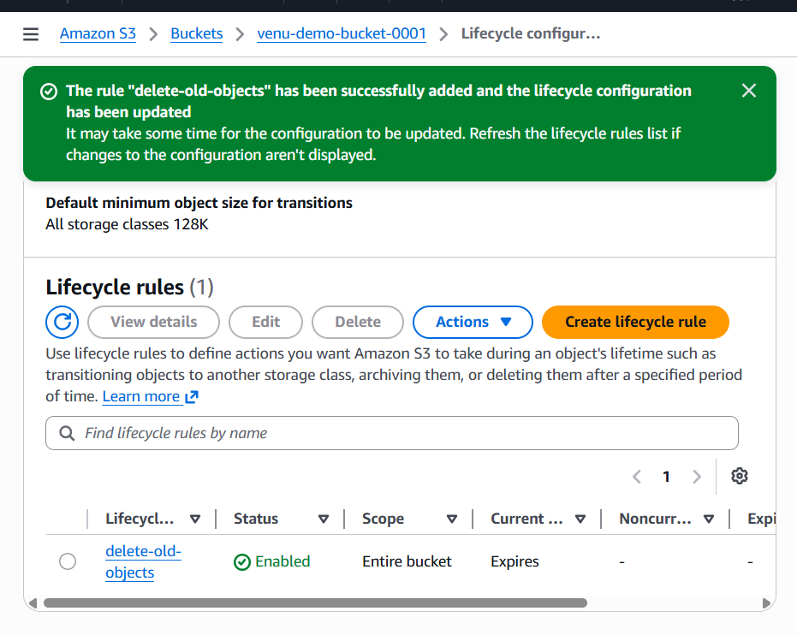

AWS CLI Commands
Create the lifecycle configuration file:
Create a file called lifecycle.json:
{
"Rules": [
{
"ID": "delete-old-objects",
"Status": "Enabled",
"Filter": {
"Prefix": ""
},
"Expiration": {
"Days": 30
}
}
]
}
Apply the lifecycle rule:
aws s3api put-bucket-lifecycle-configuration \
--bucket venu-demo-bucket-0001 \
--lifecycle-configuration file://lifecycle.json
Verify the lifecycle policy:
aws s3api get-bucket-lifecycle-configuration \
--bucket venu-demo-bucket-0001
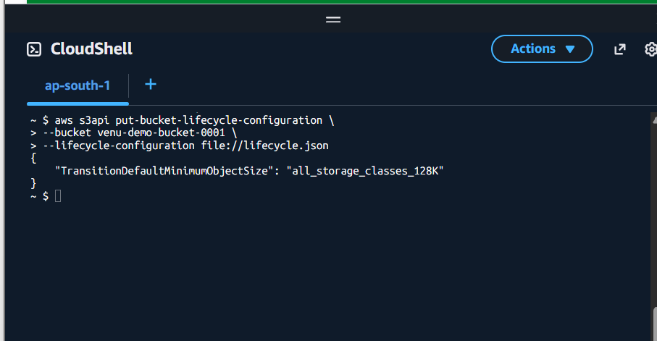

Expected Result
Objects older than 30 days will automatically be deleted from the bucket.

Screenshots to Capture
- Lifecycle rules page.
- Lifecycle rule configuration.
- Expiration settings.
- Successfully created lifecycle rule.

Key Learnings
- Learned how lifecycle policies automate object management.
- Learned how to reduce storage costs.
- Learned how to automatically delete old objects from S3.

6.Push some objects to S3 using the AWS CLI.
Objective
Upload files or objects to an Amazon S3 bucket using AWS Command Line Interface (AWS CLI).

Theory
AWS CLI allows users to interact with AWS services from the command line.
Using AWS CLI with S3, we can:
- Create buckets
- Upload objects
- Download objects
- List objects
- Delete objects
- Manage S3 configurations
The command used for uploading files is:
aws s3 cp
cp means copy. It copies files from the local machine to S3 or from S3 to the local machine.

Prerequisites
Before starting:
- AWS CLI should be installed.
- AWS CLI should be configured.
Check AWS CLI:
aws --version
Example output:
aws-cli/2.x.x Python/3.x.x Linux/x86_64
Check AWS account:
aws sts get-caller-identity
Example output:
{
"UserId": "XXXXXXXXXXXX",
"Account": "XXXXXXXXXXXX",
"Arn": "arn:aws:iam::XXXXXXXXXXXX:user/admin"
}

Step 1: Verify the S3 Bucket
Check available buckets:
aws s3 ls
Expected output:
2026-07-22 venu-demo-bucket-0001
2026-07-22 venu-demo-bucket-backup-0011

Step 2: Create a Test File
Create a sample file:
echo "Testing AWS CLI S3 upload" > cli-test.txt
Verify the file:
ls -l
Expected output:
cli-test.txt
Check content:
cat cli-test.txt
Output:
Testing AWS CLI S3 upload
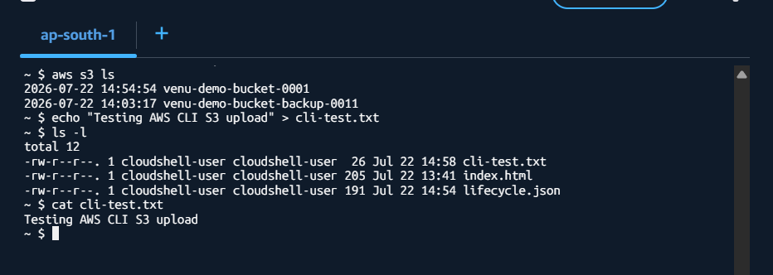

Step 3: Upload Object to S3
Upload the file to the Mumbai bucket:
aws s3 cp cli-test.txt s3://venu-demo-bucket-0001/
Expected output:
upload: ./cli-test.txt to s3://venu-demo-bucket-0001/cli-test.txt

Step 4: Verify Uploaded Object
List objects in the bucket:
aws s3 ls s3://venu-demo-bucket-0001/
Expected output:
2026-07-22 cli-test.txt

Step 5: Upload Multiple Files
Create multiple files:
touch file1.txt file2.txt file3.txt
Upload all files:
aws s3 cp . s3://venu-demo-bucket-0001/ --recursive
Verify:
aws s3 ls s3://venu-demo-bucket-0001/
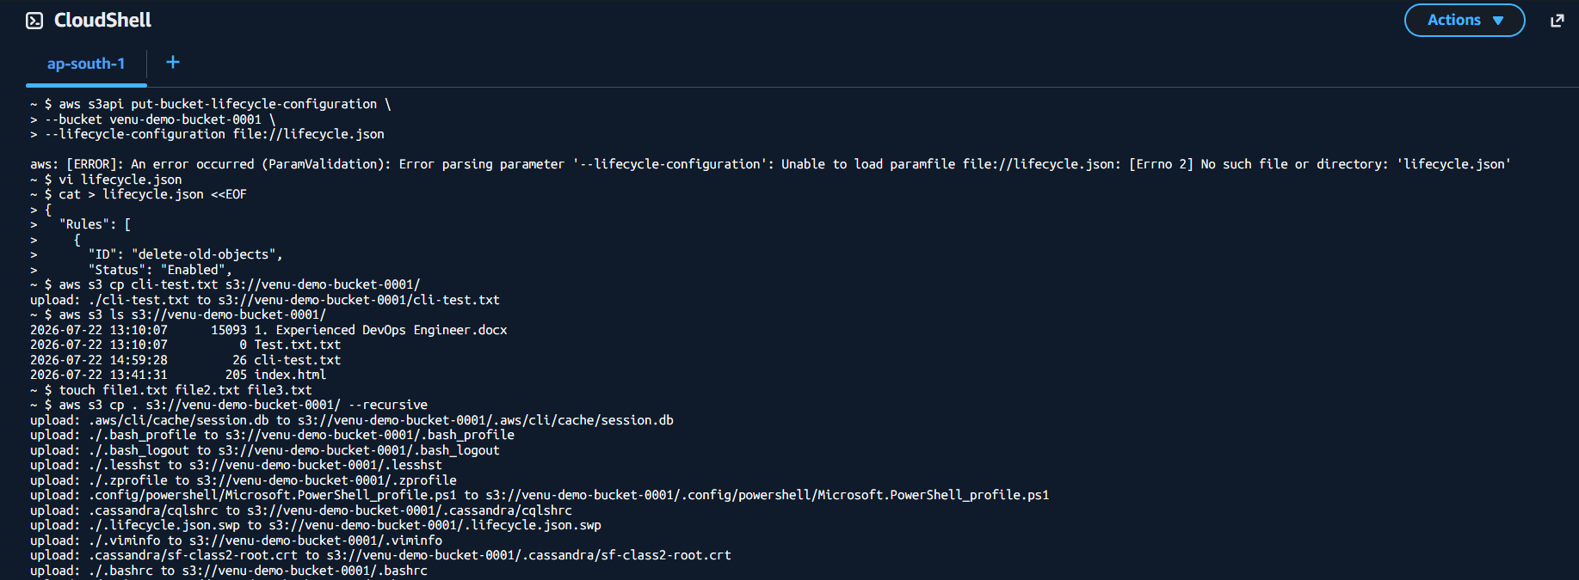
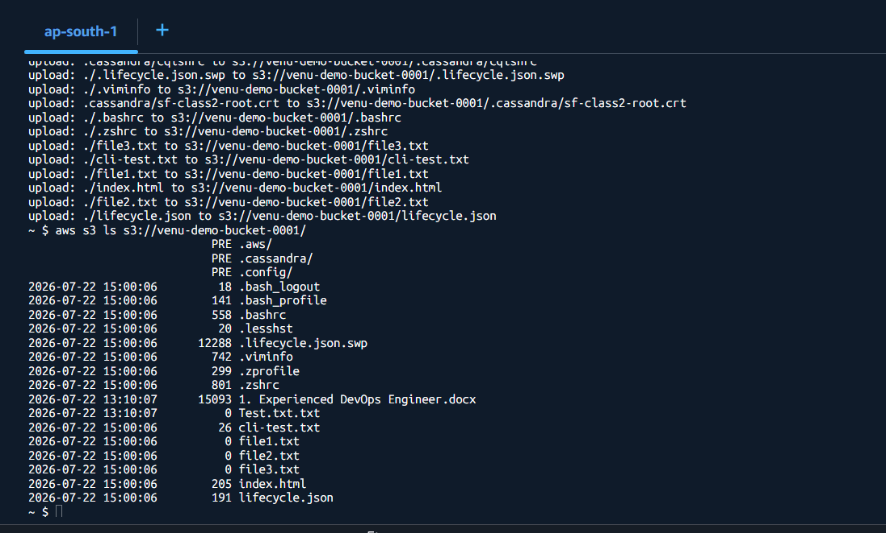

Step 6: Upload a Folder to S3
Create a folder:
mkdir s3-data
Create files:
echo "Object 1" > s3-data/object1.txt
echo "Object 2" > s3-data/object2.txt
Upload folder:
aws s3 cp s3-data/ s3://venu-demo-bucket-0001/s3-data/ --recursive
Verify:
aws s3 ls s3://venu-demo-bucket-0001/s3-data/
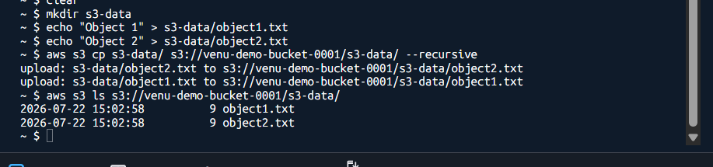

Step 7: Download Object from S3
Download a file:
aws s3 cp s3://venu-demo-bucket-0001/cli-test.txt .
Verify:
ls -l
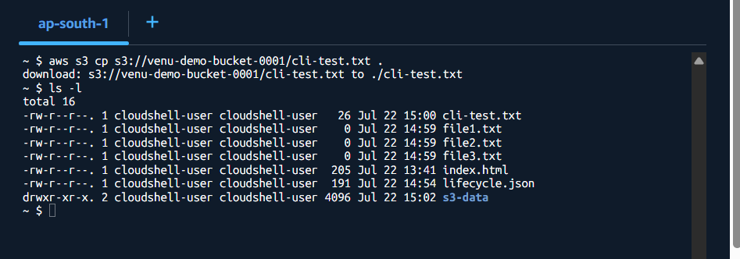

Step 8: Delete Object (Optional)
Delete a file:
aws s3 rm s3://venu-demo-bucket-0001/cli-test.txt
Verify:
aws s3 ls s3://venu-demo-bucket-0001/
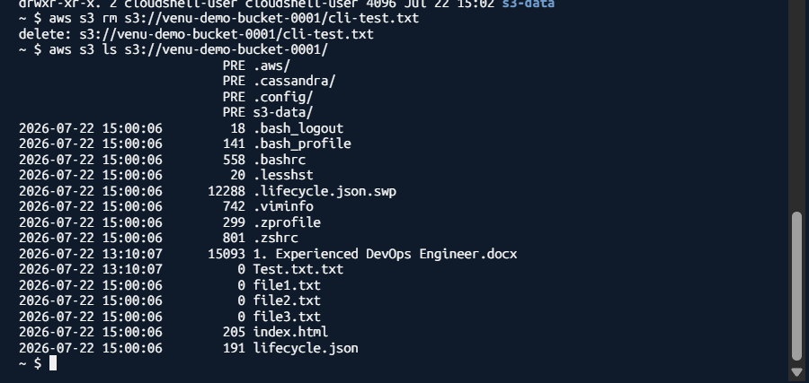

Screenshots to Capture
- AWS CLI version check.
- S3 bucket list command output.
- File creation command.
- Upload command success message.
- S3 bucket showing uploaded object.
- Download command output (optional).

Result
Objects were successfully uploaded to the S3 bucket using AWS CLI commands.

Key Learnings
- Learned how to use AWS CLI with Amazon S3.
- Learned how to upload files using the aws s3 cp command.
- Learned how to verify uploaded objects.
- Learned how to upload multiple files using the --recursive option.
- Learned basic S3 object management using CLI.

7.Write a Bash script to create an S3 bucket.
Objective
Create an Amazon S3 bucket automatically using a Bash script instead of manually creating it from the AWS Console.

Theory
A Bash script is a text file containing a sequence of Linux commands that are executed automatically.
Using AWS CLI commands inside a Bash script, we can automate AWS resource creation.
Benefits:
- Reduces manual work.
- Helps automate cloud operations.
- Useful for DevOps tasks.

Prerequisites
Before creating the script, verify:
1. AWS CLI is installed
aws --version
2. AWS CLI is configured
aws sts get-caller-identity
3. Region
We will create the bucket in:
Asia Pacific (Mumbai) - ap-south-1

Step 1: Create Bash Script File
Create a file:
vi create-s3-bucket.sh
(or use nano)
nano create-s3-bucket.sh

Step 2: Add Script Content
Paste the below script:
#!/bin/bash

# Variables
BUCKET_NAME="venu-demo-bucket-script-0001"
REGION="ap-south-1"

# Create S3 Bucket
echo "Creating S3 bucket: $BUCKET_NAME"

aws s3api create-bucket \
--bucket $BUCKET_NAME \
--region $REGION \
--create-bucket-configuration LocationConstraint=$REGION

# Enable Versioning
echo "Enabling bucket versioning"

aws s3api put-bucket-versioning \
--bucket $BUCKET_NAME \
--versioning-configuration Status=Enabled

echo "S3 bucket created successfully"

Step 3: Save the File
If using vi:
Press:
Esc
Type:
:wq
Press Enter.

Step 4: Give Execute Permission
Make the script executable:
chmod +x create-s3-bucket.sh
Check permission:
ls -l create-s3-bucket.sh
Expected:
-rwxr-xr-x

Step 5: Execute the Script
Run:
./create-s3-bucket.sh
Expected output:
Creating S3 bucket: venu-demo-bucket-script-0001

Enabling bucket versioning

S3 bucket created successfully
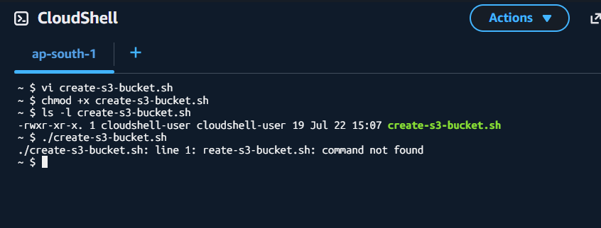

Step 6: Verify Bucket Creation
List buckets:
aws s3 ls
Expected:
2026-07-22 venu-demo-bucket-script-0001

Step 7: Verify Versioning
Run:
aws s3api get-bucket-versioning \
--bucket venu-demo-bucket-script-0001
Expected:
{
"Status": "Enabled"
}
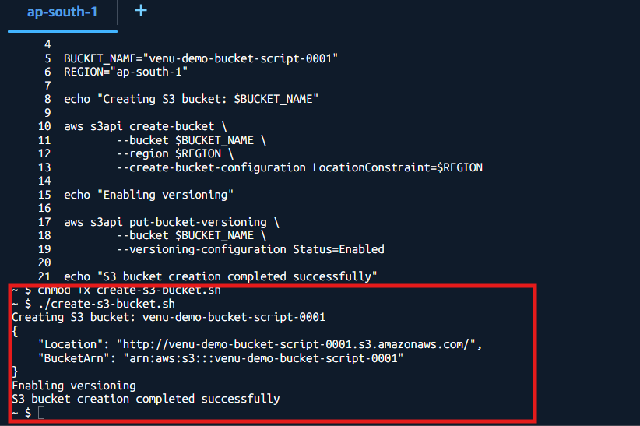

Screenshots to Capture
- Bash script file content.
- Execute permission command.
- Script execution output.
- S3 bucket created in AWS Console.
- Versioning enabled output.

Result
S3 bucket was successfully created using a Bash automation script.

Key Learnings
- Learned how to automate AWS tasks using Bash scripting.
- Learned how to use AWS CLI commands inside scripts.
- Learned how to create and configure S3 buckets automatically.
- Learned basic DevOps automation practices.

8.Upload a 1 GB file to S3 using the CLI.
Objective
Create a 1 GB file and upload it to an Amazon S3 bucket using AWS CLI.

Theory
Amazon S3 can store files of any size (up to 5 TB per object).
AWS CLI provides commands to upload large files efficiently.
For large files:
- AWS CLI automatically uses multipart upload.
- The file is divided into smaller parts.
- Parts are uploaded in parallel.
- This improves upload speed and reliability.
Command used:
aws s3 cp

Prerequisites
Use the bucket created earlier:
venu-demo-bucket-script-0001
Region:
Asia Pacific (Mumbai) - ap-south-1
Check AWS CLI:
aws --version

Step 1: Check Available Disk Space
Before creating a 1 GB file:
df -h
Check available space in CloudShell.

Step 2: Create a 1 GB File
Use the dd command:
dd if=/dev/zero of=largefile-1GB.bin bs=1M count=1024
Explanation:
Parameter | Meaning
dd | Create/copy data
if=/dev/zero | Generates empty data
of= | Output file name
bs=1M | Block size = 1 MB
count=1024 | Creates 1024 MB
Expected output:
1024+0 records in
1024+0 records out
1073741824 bytes copied

Step 3: Verify File Size
Run:
ls -lh largefile-1GB.bin
Expected:
-rw-r--r-- 1 cloudshell-user cloudshell-user 1.0G largefile-1GB.bin
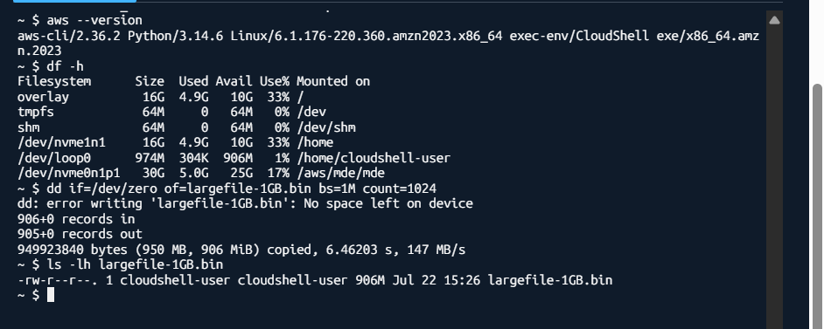

Step 4: Upload File to S3
Upload:
aws s3 cp largefile-1GB.bin s3://venu-demo-bucket-script-0001/
Expected:
upload: ./largefile-1GB.bin to s3://venu-demo-bucket-script-0001/largefile-1GB.bin
AWS CLI will automatically perform multipart upload.

Step 5: Verify Object in S3
List objects:
aws s3 ls s3://venu-demo-bucket-script-0001/
Expected:
2026-07-22 largefile-1GB.bin 1073741824
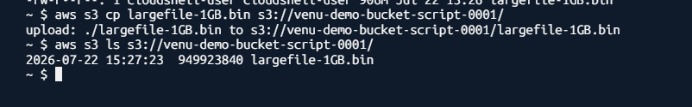

Step 6: Check Object Details
Use:
aws s3api head-object \
--bucket venu-demo-bucket-script-0001 \
--key largefile-1GB.bin
Expected:
{
"ContentLength": 1073741824
}
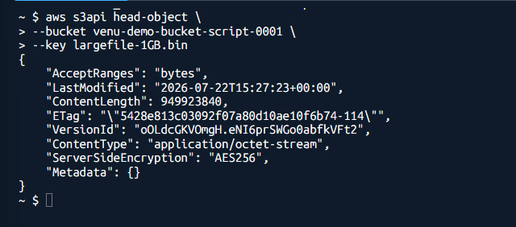

Step 7: Check Multipart Uploads (Optional)
List active uploads:
aws s3api list-multipart-uploads \
--bucket venu-demo-bucket-script-0001
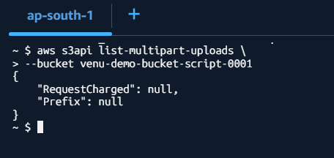

Step 8: Verify from AWS Console
- Open:
S3 → venu-demo-bucket-script-0001
- Go to Objects.
- Verify:
largefile-1GB.bin
- Check size:
1 GB
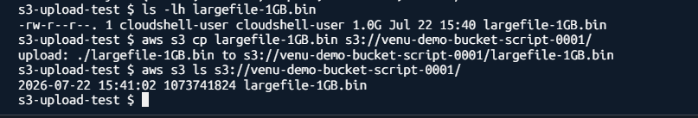

Step 9: Clean Up (Optional)
If you don't need the 1 GB file anymore:
Delete from S3:
aws s3 rm s3://venu-demo-bucket-script-0001/largefile-1GB.bin
Delete local file:
rm largefile-1GB.bin
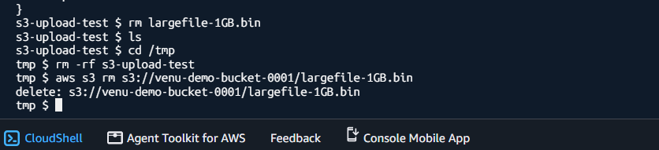

Screenshots to Capture
- File creation command:
dd if=/dev/zero of=largefile-1GB.bin bs=1M count=1024
- File size verification:
ls -lh largefile-1GB.bin
- Upload command:
aws s3 cp largefile-1GB.bin s3://venu-demo-bucket-script-0001/
- S3 console showing 1 GB object.
- Object metadata showing size.

Result
A 1 GB file was successfully created and uploaded to Amazon S3 using AWS CLI.

Key Learnings
- Learned how to create large files in Linux.
- Learned how AWS CLI uploads large files.
- Learned about S3 multipart upload.
- Learned how to verify uploaded object size.

